Student Handout on Pottery
What is clay? It is earthen material that soft and can easily be formed to make bricks, title, and pottery.
What is pottery? Pottery is fired clay that becomes hard and can be used as containers for cooking, eating, and storing food.
What is coiled pottery? The American Indians in Georgia made coiled pottery. Coiled pottery is done to build thicker or taller walled vessels by rolling long pieces of clay then putting it on top of one another.
How to make your own pottery like the American Indian over 1,000 years ago!
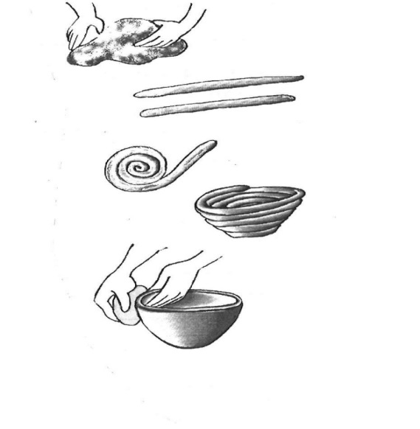
- Pinch off some clay (golf ball size) and make it into a ball
- Take your ball and make a pancake out of it. But not too thin.
This will be the bottom of your pot.
- Roll another piece of clay into a coil (like a snake) then wrap it around the top of your pancake.
- Make four coils to put on top of your pancake.
- After four coils (it should look like a pot; if not add more coils) take your finger and smooth and blend the clay until it is smooth. (Do not squeeze the clay to smooth)
- While the clay is damp you can now decorate it with designs.
- You can use sticks, pencils, or other objects.

